AM420 – Aerodynamics
Pressure Distribution on Airfoils

(Revised by G. Dewar for ELD Wind Tunnel - Oct. 2000)

- Introduction

The forces on a body moving through a fluid are the result of the pressure and shear stress distributions over the surface of the body. The resultant force can then be resolved into the lift and drag components. The purpose of this laboratory is to measure the pressure distribution over the surface of two NACA airfoils and use these measurements to calculate the resulting aerodynamic forces on the airfoils. These measurements can then be compared to known results.

- Laboratory Information

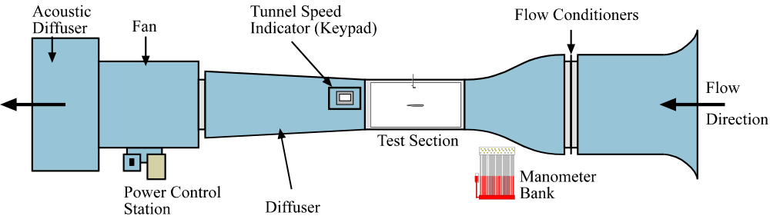

Figure 1: Low Speed Wind Tunnel.

The low speed wind tunnel (figure 1) is fitted with a 6-inch chord length NACA airfoil in its 18-inch by 18-inch test section. The airfoil has 18 pressure taps along its length, the positions of which can be found in the appendix section of this handout. These pressure taps are connected via tubing to a pressure transducer and digital readout assembly. A Pitot probe (measuring P_{T}) and static tap (measuring 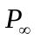) are installed in the wind tunnel to determine the freestream velocity.
The digital readout assembly is connected to a PC for retrieval of the data (see Figure 2). A Labview program will be used to carry out the experiment. The program will collect differential pressures 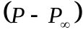 for each port (1 through 18) and Pitot-static pressure 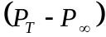 at the designated Reynolds number. The computer sets the speed of the tunnel from the Reynolds numbers the user inputs at the start of the program, as described in part 4 of this report. The required Reynolds number will be supplied by the Teaching Fellow.
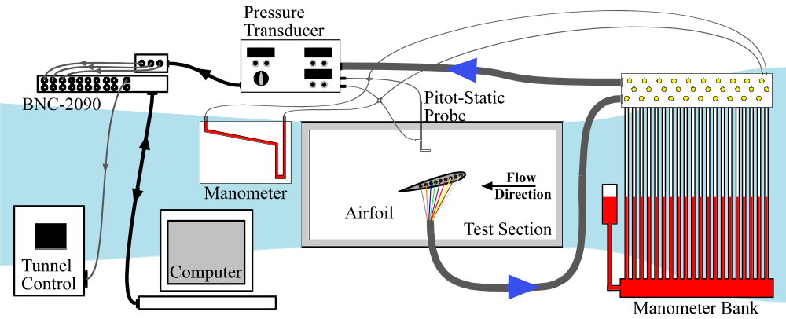

Figure 2: Experimental Setup for Tunnel Test Section

To read the pressure at each port turn the dial on the digital readout assembly to the appropriate port number. Port ‘0’ reads the Pitot- static pressure , while ports ‘1’ through ‘9’ reads the differential pressure at a designated location on the airfoil surface.
The airfoils are a 6-inch chord length NACA 0012 symmetric airfoil with 18 surface pressure ports spaced along the upper surface of the airfoil from the leading edge to near the trailing edge, and a 6-inch chord NACA 4412 airfoil with 18 surface pressure ports spaced around the surface of the airfoil, with 1 at the leading edge, 9 on the upper surface and 8 on the lower surface. The positions of the 18 pressure ports on each airfoil are shown in figures 3a and 3b, with the corresponding position and angle data being given in the appendix section of this handout.

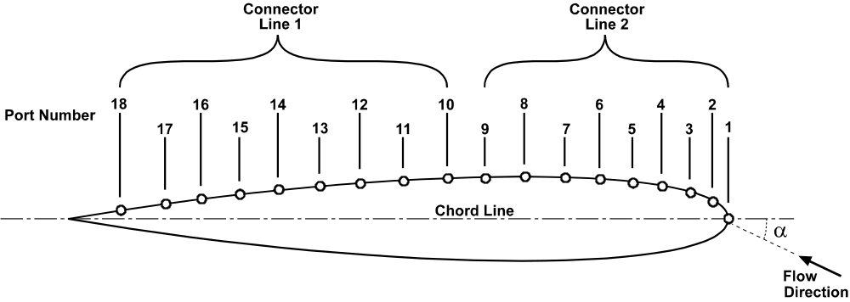

Figure 3a: Coordinate system for NACA0012 Airfoil.
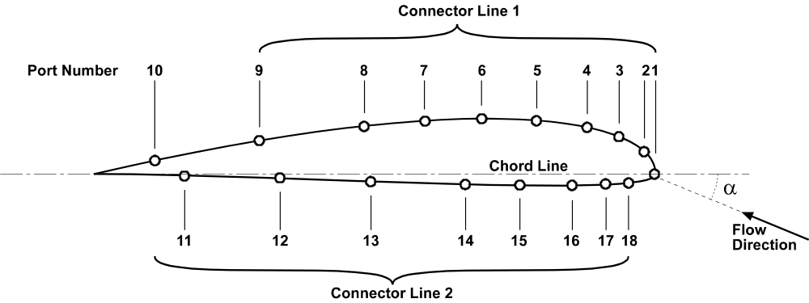

Figure 3b: Coordinate system for NACA4412 Airfoil.

Ports 1 through 9 and 10 through 18 are attached to the tubing bundles, which are in turn attached to the manometer bank. The pressure transducer can only take measurements for one bundle at a time, so during the experiment the control valves on the manometer bank will have to be set to allow the required pressure to be measured by the transducer (Note: the experimental procedure is given in section 4 of this handout). The angle of attack, α, for the airfoil can be controlled by rotating the airfoil within its housing using the attached handles.
The valves above the manometer bank control the direction of the pressure readings from the airfoil. The bottom two rows control the manometer bank while the top set of valves control which pressures are sent to the transducer.

For the NACA 0012 airfoil, as the airfoil is symmetric, taking readings for a negative angle of attack provides data equivalent to that on the lower surface of the airfoil when at the corresponding positive angle of attack. For this laboratory, profiles will be taken at angles given by the TF, with the results for the equivalent negative angle of attack being combined with those for the positive angle of attack to give a complete profile for the required angle. Note that for a symmetric airfoil at 0º, the upper and lower surface profiles are equivalent.
For the NACA 4412 airfoil however, the pressure ports are spread over both the upper and lower surfaces, so a full profile can be obtained directly at the required angle of attack.
The ‘zero’ position for the airfoil is indicated by a red mark on the rim of the housing. To set the airfoil to zero degrees line up this mark with the corresponding ‘0’ mark on the tunnel test section wall. An indicator card on the airfoil housing is marked at 4º intervals. To set α to the required angle, line up the appropriate mark on the indicator card with the ‘0’ mark on the tunnel.

- Theory

The freestream velocity can be calculated from the differential pressure 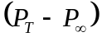, where 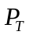 is the total pressure measured by the Pitot-probe, and 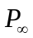 is the static pressure measured from the static tap. The freestream velocity, 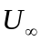, can then be found from Bernoulli’s equation;

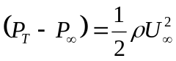 (1)

The corresponding Reynolds number can then be found;

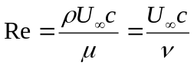 (2)

where c is the chord length of the airfoil. If the differential pressure is known at a point on the surface of the airfoil, the coefficient of pressure at that point can then be defined as;

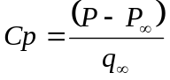 (3)
where,
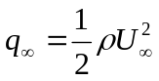 (4)

Defining the resultant force per unit span along the direction of the chord as A’ and the resultant force per unit span normal to the chord as N’, the lift and drag on an airfoil can be defined as:

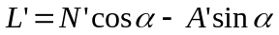 (5)
and
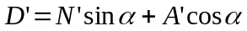 (6)

where the lift per unit span ,L’, is defined as the resultant force normal to the freestream velocity and the drag per unit span ,D’, is the resultant force in the direction of the freestream velocity. The angle of attack, α, is defined as the angle between the chord and the freestream velocity (see figure 4).

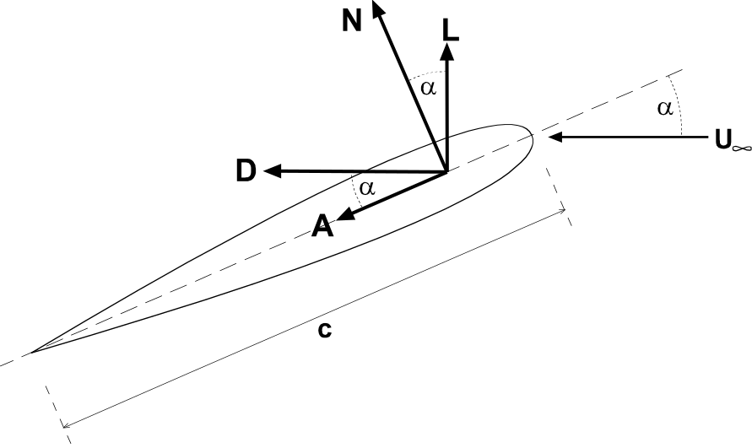
Figure 4: Resultant aerodynamic forces on airfoil.

The angles at which the pressures on the surface of the airfoil act are defined in figure 5. The angle, θ, at each port on the airfoil is given in the appendix. The subscripts ‘u’ and ‘l’ correspond to ‘upper’ and ‘lower’ respectively.

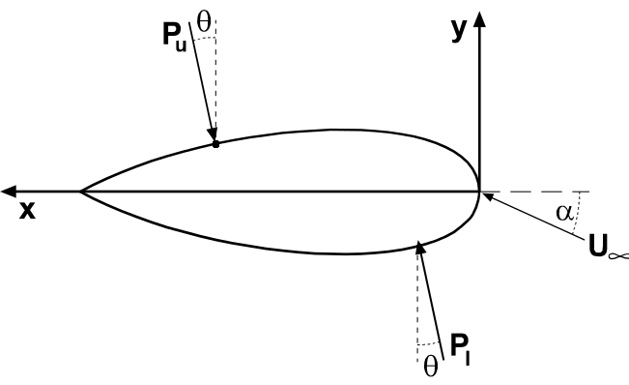
Figure 5: Nomenclature for Pressure Distribution on airfoil surface.

Neglecting the contribution of the shear stress, and using the thin airfoil theory (where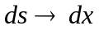), the normal and axial forces per unit span are;

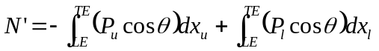 (7)
and
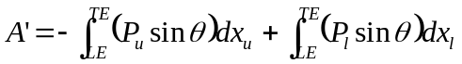 (8)

Discretizing these integrals gives the equations;

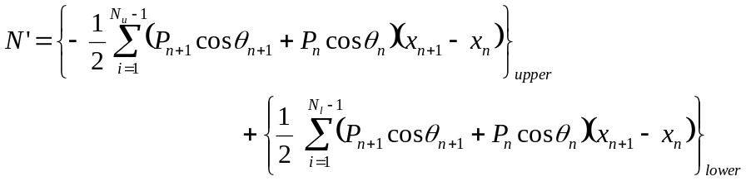 (9)
and
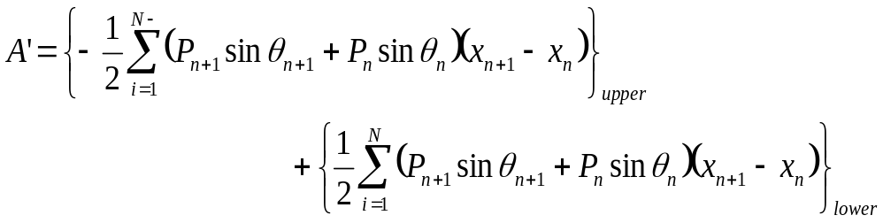 (10)
Here, N_{u} and N_{l} correspond to the number of pressure ports on the upper and lower surfaces respectively (ordered from leading edge to trailing edge). These values can then be inserted into equations (5) and (6) to obtain the lift and drag forces per unit span. The coefficients of lift and drag can then be calculated using:

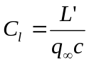 (11)
and,
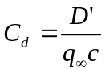 (12)

- Experimental Procedure

For this lab, the TF will have carried out the transducer calibration before the lab begins. The values obtained (i.e. ‘slope’ and ‘intercept’) can then be used with the calibration equation to calculate the pressure from the transducer voltage at each port. The calibration equation is:

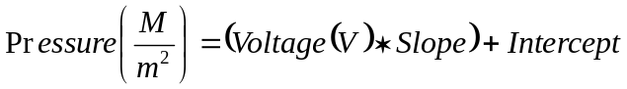

This procedure is to be carried out for each of the airfoils. Remember, for the NACA 0012 symmetric airfoil, data must be taken at both the positive and corresponding negative angles of attack to obtain a full profile.

WARNING: Be extremely careful when handling airfoils! Do not remove or insert an airfoil unless the TF is present.

WARNING: Do not open tunnel test section if airfoil is in tunnel!

WARNING: Do not turn the airfoil by grabbing on to the attached tubes. Use the handles provided!

WARNING: Failure to set transducer to correct position will ruin experiment.

- Open Labview program ‘Airfoil(pressure)’ from the Am420\Lab 2 folder.

- Input required information into 'INPUTS' panel.

- Make sure TF has input Calibration data for pressure transducer and tunnel speed indicator.

- Make sure Pressure Selector on Digital Readout Assembly is set to port '0'. (Note: this gives the Pitot Probe reading)

- Set the bottom two sets of valves above the manometer bank to ‘fully open’ (i.e. allowing pressure readings both to the manometer bank and transducer).

- Set the top set of valves above the manometer bank to open ports ‘1’ through ‘9’ only.

- Make sure Pitot Probe is positioned correctly (i.e. X = 0m, Y = 0.368m on readout assembly).

- Place airfoil at the required angle of attack.

- Left click 'Play' button (top left of screen) to start program.

- Left click on 'START TUNNEL' button to turn tunnel on.

- Wait until tunnel has reached steady state (i.e. the output frequency reading on the Tunnel Speed Indicator and the manometer bank readings are constant).

WARNING: Failure to wait until the tunnel has reached steady state will result in bad results!

- Left click on 'CALIBRATE SPEED' button to set tunnel to speed corresponding to required Reynolds number.

- Wait until tunnel has again reached steady state.

- Observe readings for pressure profile on manometer bank ports 1 through 18.

- Close valves to manometer bank (turn handles on bottom two sets of valves to point downwards), thus allowing only transducer to read pressures.

- Left click on 'TAKE READING' button to read differential pressure from pressure transducer for port '0'.

- Spot check: After taking the Pitot Probe reading (port '0'), check that the measured differential pressure corresponds to the Reynolds number input using Bernoulli's equation and the Reynolds number equation.

- Turn Pressure Selector to port '1'.

- Left click on 'TAKE READING' button to read differential pressure for port '1'.

- Repeat steps xvi and xvii for ports '2' through '9'.

- Set the top set of valves above the manometer bank to open ports ‘10’ through ‘18’ only.

- Turn Pressure Selector dial on Digital Readout Assembly to port '1'.

- Take readings 10 through 18 by again repeating steps xvi and xvii for ports '1' through '9'.

- On completion of program tunnel will turn off automatically.

- Output Data (port number and corresponding pressure transducer voltage) will be sent to the file indicated in the 'OUTPUTS' panel. (Note: remember that port number '0’ corresponds to the Pitot static probe reading).

- Open Labview program ‘Airfoil(stall)’ from the Am420\Lab 2 folder.

- Following the instructions given in the program, use the manometer bank to investigate the positive and negative stall angles for the airfoil.

- Repeat this procedure for each airfoil.

- Required Calculations & Analysis

- For each airfoil and angle, calculate the non-dimensional pressure coefficient at each port.

- For each airfoil and angle, plot Cp versus x-position over the full airfoil surface.

- Tabulate port number, x-position, differential pressure and Cp for each airfoil and angle.

- For each airfoil and angle, calculate N’, A’, L’ and D’.

- For each airfoil and angle, calculate C_{l} and C_{d}.

- Tabulate α, velocity, N’,A’, L’, D’, C_{l} and C_{d}.

- Tabulate the stall angles for each airfoil. Comment on stall properties of each airfoil.

- Compare your results to those given in Abbott & Von Doenhoff.

- Laboratory Report Format

The purpose of this lab is not only to apply your understanding of aerodynamics to a simple experiment but also to give you practice in communicating your findings. As such, the quality of the writing will be evaluated in terms of grammar, spelling, clarity, organization, and legibility and legibility of figures and tables. The report should be understandable by someone who is not necessarily familiar with the specifics of the lab. The quality of the writing will count for a portion of your grade.
Reports must be typed, double-spaced with suitable margins. Please use only one side of the page, normal white paper; forgo fancy covers. The following format is required for the organization of the report:

- Title page
- Introduction
- Theory and Methods
- Results and Analysis
- Discussion and Conclusions
- Appendices (e.g. data, sample calculations)

The Title page should include the title of the lab, the names of all members of the lab group, as well as the date on which the lab was performed. Please make this a separate page.
The Introduction section should briefly state in your own words what you are trying to do and why you are doing the experiment. Do not simply copy or paraphrase the appropriate sections of the lab handout.
The section on Theory and Methods should explain the relevant theory, measurement techniques, and procedures for the lab. Please be complete and sufficiently detailed so that someone who has not performed the lab can understand your report. Derivations of equations used in your analysis are appropriate. Again, do not simply copy or paraphrase the appropriate sections of the lab handout.
In the Results and Analysis section, you should summarize and explain the results of the experiment, including charts and graphs. Graphs should be plotted to best show the information gained from the experiments, i.e. use linear or log scaling where appropriate, plot experimental data as individual points and theoretical data and computational data as continuous lines, and make sure all axes and data curves are clearly labeled. This section should be strictly factual, pointing out agreement and discrepancies between your results and those predicted by theory. All numerical results should be non-dimensional or reported in SI units. This is where most of the items you calculate and plot in the ‘Required Calculations and Analysis’ section should go.
For the Discussion and Conclusions, examine whether the lab satisfies the stated purpose, explaining what you have learned. Also postulate why any differences might have arisen between the theoretical (or standard experimental) values and your own results.
The Appendices should contain relevant information that is not in the body of the lab report, such as the original data sheets and details of calculations made both in lab and as part of your data analysis. Sample calculations should either be typeset or neatly written in ink.
If you rely on information from textbooks or other references, cite the references in appropriate bibliographical style. Quoting references without citing sources is plagiarism.

Appendix 1: Airfoil Information

NACA 0012

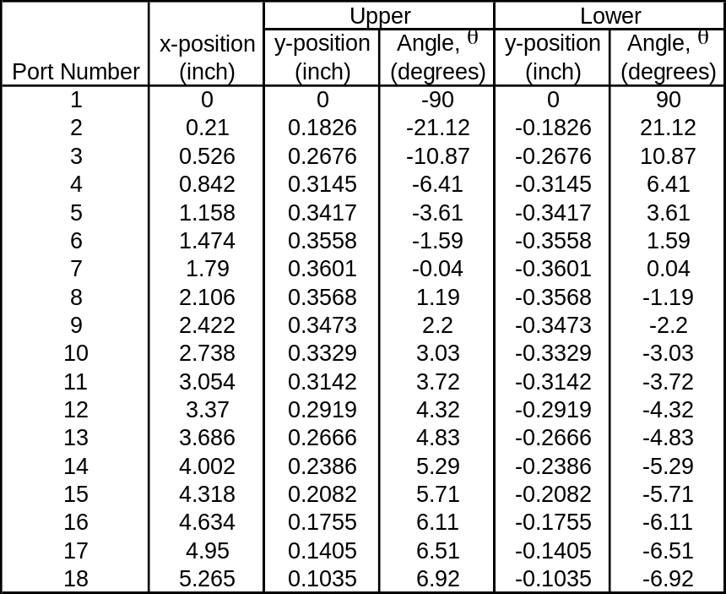

NACA 4412

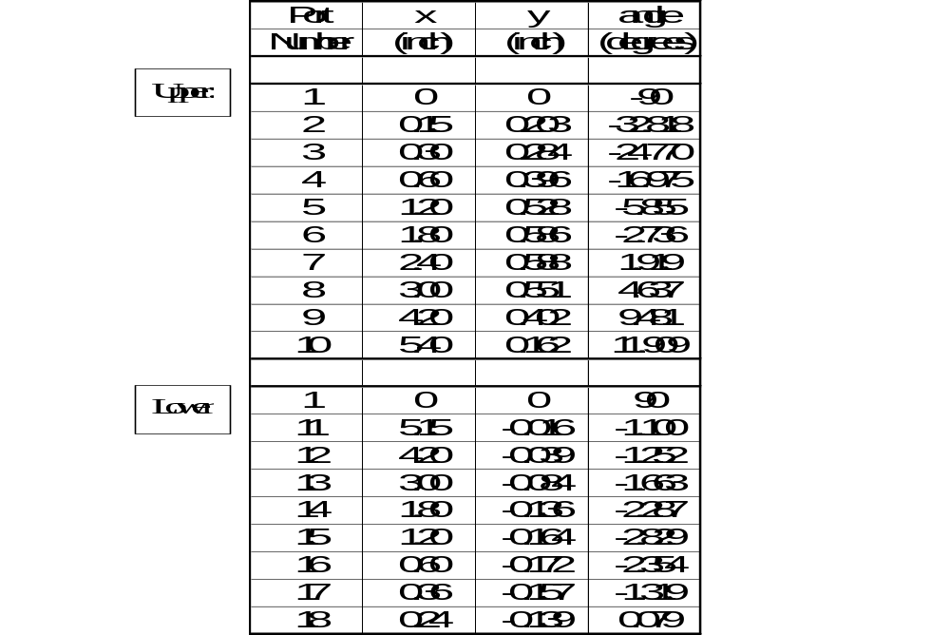

Appendix 2: Data Sheet

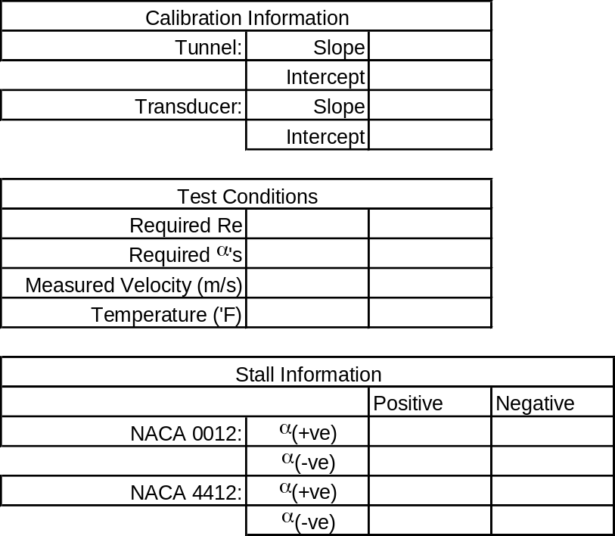

Appendix 3: Airfoil Data

Airfoil data for both NACA 0012 and NACA 4412 airfoils are given on the following pages. This data was obtained from:

Abbott, I. H. & Von Doenhoff, A. E., ‘Theory of Wing Sections’, Dover Publications Inc., New York, 1959.

